Answer the following questions on your scan sheet. Show all work on the scratch paper provided.
1 Which expression could be used to solve the problem below?
To cater a luncheon, a hotel charges $50 per hour for use of a dining room plus $24.50 per person. What is the total cost for a 2-hour luncheon for 45 people?
A 2 × 50 + 24.50 + 45
B 2 × 50 + 24.50 × 45
C 2 × 24.50 + 50 × 45
D 2 × 45 + 50 × 24.50
2. The table shows the distance Pedro jogged each day last week:
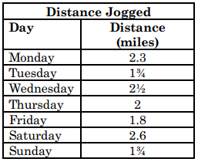
What was the total distance Pedro jogged last week?
A 8.7 mi
B 11 mi
C 14.7 mi
D 16 mi

3. Susan has 3 siblings: Ted, Kathy, and Jake. Susan is older than Jake. Ted is younger than
both his sisters but older than his brother. What information is needed to determine the
order of the siblings from oldest to youngest?
A Is Kathy older or younger than Ted?
B Is Jake older or younger than Susan?
C Is Susan older or younger than Kathy?
D Is Ted older or younger than Jake?
4. What is the value of the expression
(3 + 3)² ÷ 6 – 2 × 4?
A –18
B –2
C 0
D 16
5. Mrs. Gutiérrez bought 2 dozen cans of
soda priced at 6 cans for $1.98 and 18
bottles of water priced at 6 bottles for
$2.16. What is the total amount she
spent, not including tax, on soda and
bottled water?
A $6.48
B $7.92
C $14.40
D $16.56

6. A bowler scored between 195 points and
215 points per game. Which is the best
estimate of the total points she scored in
8 games?
A From 1,350 to 1,550
B From 1,550 to 1,750
C From 1,750 to 1,950
D From 1,950 to 2,150
7. Mrs. Vega needed to make 2 costumes for a
school play. The larger costume required
$4\frac{1}{4}$ yards of material, and the smaller costume
required $\frac{3}{4}$ yards less than the larger one.
Which equation can be used to find n, the
number of yards of material needed for the
smaller costume?
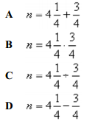

8. Mrs. Palmer started a new business and hired
12 employees. A list of the employees and their
hourly wages is shown below.
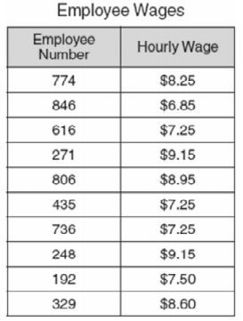
What should Mr. Palmer do to organize the
data in order to identify which employees earn
more than the median hourly wage?
A He should add up all the hourly wages and
divide by number of employees.
B He should list the employee numbers in
order from greatest to least.
C He should list the hourly wages in order
from least to greatest with their
corresponding employee numbers.
D He should list the employee numbers in
order from least to greatest with their
corresponding hourly wages.

9. Hilda bought 4 orders of french fries at $0.67
each, 3 hamburgers at $1.28 each, and 4 shakes
at $2.25 each. She paid 8.25% tax on the whole
order. What other information is necessary to
find Hilda’s correct change?
A Total cost of the order
B Amount she paid in tax
C Amount she gave the cashier
D Reason for buying the food

10. A sports-shop owner bought some baseball cards and then sold them for $7.50 each. He sold 150 cards
on Monday and 82 cards on Tuesday.
What piece of information is needed to find the amount of profit he made from the sale of the baseball cards on Monday and Tuesday?
A How much the shop owner paid for the baseball cards
B Number of cards sold on Wednesday
C Total number of cards sold
D Number of football cards bought by the shop owner

11. Simplify the expression below.
A 7
B 6
C 2
D 8
12. It is estimated that 20.4% of the U.S.
population in the year 2050 will be over the
age of 65. Which number is NOT equivalent to
20.4%?
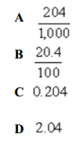

13. Peaches are on sale at $0.95 per pound. Mrs.
Hinkle bought 2.75 pounds of peaches. About
how much did she pay for the peaches?
A Less than $1.00
B Between $1.50 and $2.00
C Between $2.50 and $3.00
D More than $3.00
14. Ms. Abbot went on a road trip. The trip was
792 miles, and the average price of gasoline
was $1.30 per gallon. What information is
needed to find the amount Ms. Abbot spent on
gasoline for the trip?
A Number of hours the trip took
B Number of miles per hour the car traveled
C Average number of miles the car traveled
per gallon of gasoline
D Average number of miles Ms. Abbot drove
per day

15. A farmer knows the length and width of his
rectangular pasture. He also knows how many
pounds of fertilizer to spread per square yard.
What additional information does the farmer
need to know in order to determine the number
of bags of fertilizer he should buy?
A The type of grass in his pasture
B The number of bags of fertilizer his truck
will hold
C The price of each bag of fertilizer
D The number of pounds of fertilizer in each
bag

16. The drawing below shows the rotor of a
helicopter:
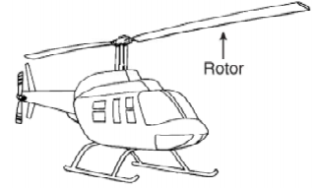
This helicopter has a rotor that moves at a rate
of 500 spins per minute while flying. Which
statement is best supported by this
information?
A The helicopter rotor will spin 2,000 times
in 40 minutes.
B The helicopter rotor will spin 4,000 times
before lifting the helicopter off the ground.
C The helicopter rotor will spin 15,000 times
in 3 hours.
D The helicopter rotor will spin 30,000 times
in 1 hour.

17. Arthur uses his own tractor while doing various
jobs. He is paid a flat fee of $100 for each job.
In addition to the flat fee, he is paid $20 for
each hour he works with the tractor. Which
shows how to find the amount Arthur should be
paid for working with the tractor for 10 hours?
A Add 20 to 10 and then multiply the sum by
100
B Multiply 100 by 10 and then add 20 to the
Product
C Multiply 20 by 10 and then add 100 to the
Product
D Add 20 to 100 and then multiply the sum
by 10

18. Nora wants to save $82.50 to buy a special gift
for her mother. She has 15 weeks to save the
money. If she wants to save the same amount
each week, how much money, in dollars and
cents, must Nora save each week?
A 4.5
B 5.5
C 6.5
D 7.5

19. Stephanie makes cocoa mix to sell at the winter fair. She makes 230 cups of one flavor of cocoa mix and 180 cups of another flavor. To package the cocoa mix, Stephanie needs to purchase containers that hold 2 cups each. The containers are sold in boxes of 50.
Which would be the correct order for Stephanie to do
the following steps to find the number of boxes of containers she needs to buy?
Step R: Divide the total number of cups of cocoa mix by 2.
Step S: Find the sum of the numbers of cups of the two different types of cocoa mix.
Step T: Divide the number of containers needed by 50 to find the number of boxes of containers to buy.
A R, S, T
B S, R, T
C T, R, S
D R, T, S
20. In a survey, students were asked
whether they play basketball or tennis.
Of 34 students, 24 students play basketball, 13 students play tennis, and 4 students do not play either sport. How many students play both sports?
A 41
B 11
C 7
D 4

